| **ECON 211-001 (1094)**  **Intelligent Economics:**  An Explainable AI Approach  **2021 Autumn Term (Seven Week – Second Session)** |  |
| --- | --- |

**Instructor**: Luyao (Sunshine) Zhang | Ph.D. in Economics

**Teaching Assistants**:

Chenyu Wang: [chenyu.wang004@dukekunshan.edu.cn](mailto:chenyu.wang004@dukekunshan.edu.cn)

Jingwei Li: [jingwei.li698@dukekunshan.edu.cn](mailto:jingwei.li698@dukekunshan.edu.cn)

Xinyu Tian: [xinyu.tian@dukekunshan.edu.cn](mailto:xinyu.tian@dukekunshan.edu.cn)

Tianyu Wu: [tianyu.wu136@dukekunshan.edu.cn](mailto:tianyu.wu136@dukekunshan.edu.cn)

Zesen Zhuang: [zesen.zhuang@dukekunshan.edu.cn](mailto:zesen.zhuang@dukekunshan.edu.cn)

Econ 211 Gradescope

The future of grading

# Introduction

Gradescope can help the instructor to properly administer and grade all of the assessments, no matter online or in-class, and it is designed to save time grading and get a clear picture of how the students are doing. This platform supports all subjects to be graded, including Computer Science, Economics, Mathematics, Engineering, etc. It creates a platform for the instructor to make a profile of all the assignments that have been designed, including exams, homework, and codes. At the same time, it supports a quick and flexible grading experience by applying detailed feedback with a simple click. Moreover, Gradescope also supports visualization of the rubric level and overall statistics to better understand the students’ progress. This platform also explores the potential AI-assisted grading experience by applying Natural Language Processing techniques to classify the students’ assignments and thus enable the instructor to grade by group. Overall, this platform optimizes the grading experiences and makes the hands-on experience more efficient.

# How Gradescope: a step-by-step guide

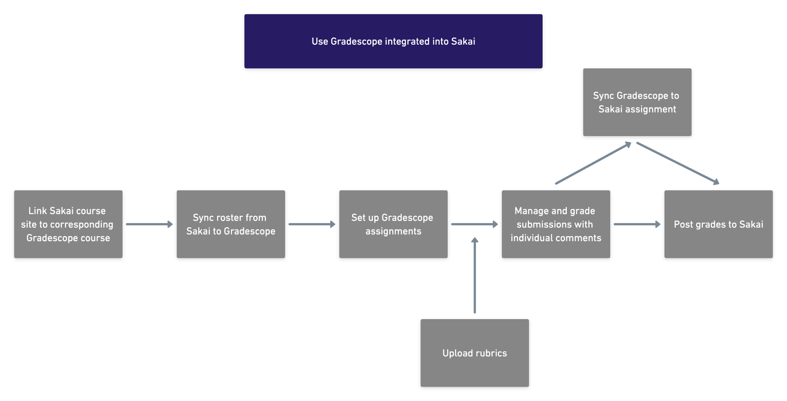

By enabling Gradescope as a tool in Sakai, the instructor and students can directly have the access to Gradescope website for assignment submission and grading. For the instructor, through syncing the Sakai course site to the corresponding Gradescope course, rosters and future grade posting will be automatically implemented from Gradescope to Sakai. After the sync is done, instructors can start to set up Gradescope assignments according to their demands, such as problem sets, quizzes, code assignments, or other customized homework formats created by beta version, where it also allows individual or group submission. After the deadline, the instructor can start to grade students’ submissions based on imported or designed rubrics, and it can be synced directly with the corresponding assignment in Sakai, thus students can check their grades either from Sakai or Gradescope. Every submission will be evaluated on an individual basis properly, with clear comments and grades based on rubrics. It is also convenient for students to check their grades and feedback directly from Gradescope.

# Pros and Cons

Summary:

Gradescope is generally a user-friendly integrated platform for assignment submission and grading. We have figured out several pros and cons in our use as both students and TAs. We highly appreciate the integrated functionality of Gradescope but think some details need more attention.

Pros:

1. **The integrated functionalities:** Gradescope allows instructors/TAs to

(1) upload assignments and attachments;

(2) set up sub-questions and specific answer positions with the beta version;

(3) upload grading rubrics and add additional comments, and (4) review and export grades, and students to upload their assignments with tags for every question.

1. **Free access and connection with Sakai:** Gradescope is connected with Sakai, which provides free access for instructors, TAs, and students.
2. **User-friendly operations:** The web pages of Gradescope are clear and instructive. Users can easily customize the assignments and grading procedure.

Cons:

1. **Rubrics uploading:** The grading rubrics can only be uploaded after at least one submission of the assignment. And the rubrics cannot be replicated from another assignment.
2. **Auto-grading tools:** There are no auto-grading tools to grade the assignments.
3. **Complex assignment grading:** Complex assignment grading can only be done by setting sub-questions. And there are no logic settings within the sub-questions.

# Essay Assignment

Econ 101, 3 Problem Set, Essay, Prerequisite Require Document 1-3.

In ECON101, we have in total 3 problem sets that use Gradescope. In each problem set, the students are asked to write a 3-part essay with a flow chart and several illustrative figures and tables. For the problem set assignments, we have the following help documentation: [[Problem Set 1 Instruction](https://docs.google.com/document/d/1cZMQYbtZd3Sw7hyOwshi7U2tjQSZL0od/edit?usp=sharing&ouid=100834953244531798659&rtpof=true&sd=true)][[Problem Set 2 Instruction](https://docs.google.com/document/d/1NA9faMbosO5zie6oeKeX60zaCCwBfbB8/edit?usp=sharing&ouid=100834953244531798659&rtpof=true&sd=true)][[Problem Set 3 Instruction](https://docs.google.com/document/d/1XNeI5_ZI2T2FrmHYdPYR7ypterwWhb8Q/edit?usp=sharing&ouid=100834953244531798659&rtpof=true&sd=true)][[Submission Guideline](https://drive.google.com/file/d/1TLadPgDNYDeiUFhrL4EqoYlm2pC38mT9/view?usp=sharing)][[Requirements/Grading Rubrics](https://drive.google.com/file/d/1nMqJ7Og6LzbxdGp0Sbj1X_ZhECcSPons/view?usp=sharing)]

In general, we ask students to submit their assignments onto Gradescope and we use it for grading. Figures 1-5 show the functionality of Gradescope:

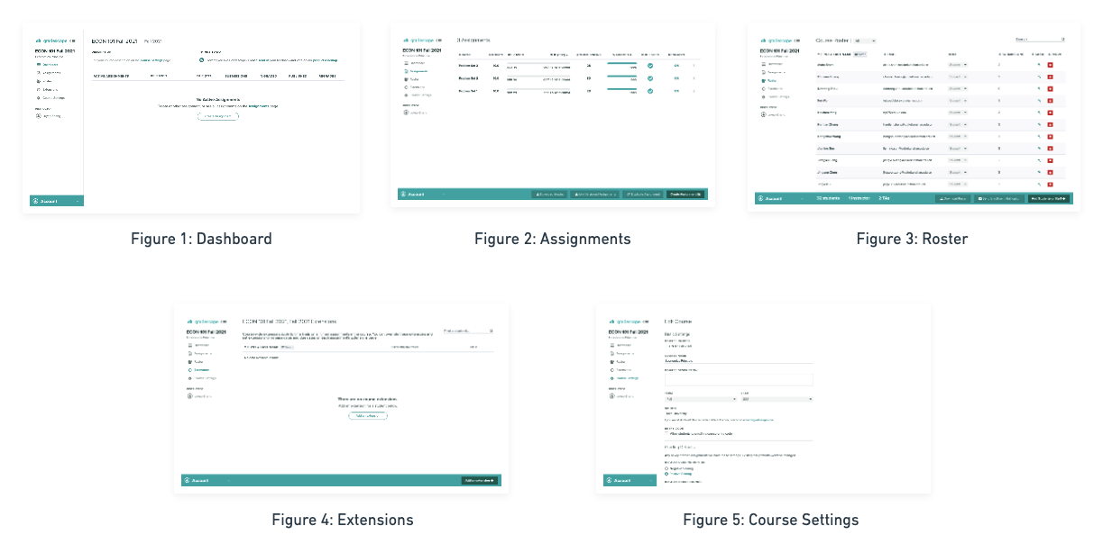

There are 5 functional pages in Gradescope:

1. Dashboard (visible in student view): Allows students and instructors to view the active assignments and course description.
2. Assignments (invisible in student view): Allows instructors and TAs to check the status of the assignments.
3. Roster (invisible in student view): Allows instructors and TAs to add or delete course members.
4. Extensions (invisible in student view): Allows instructors and TAs to add specific time extensions to assignments.
5. Course Settings (invisible in student view): Allows instructors and TAs to set up the course and customize the grading styles.

In each assignment, we use the beta version to add sub-questions under one assignment. Figures 6-9 show the functionality of Gradescop in grading assignments:

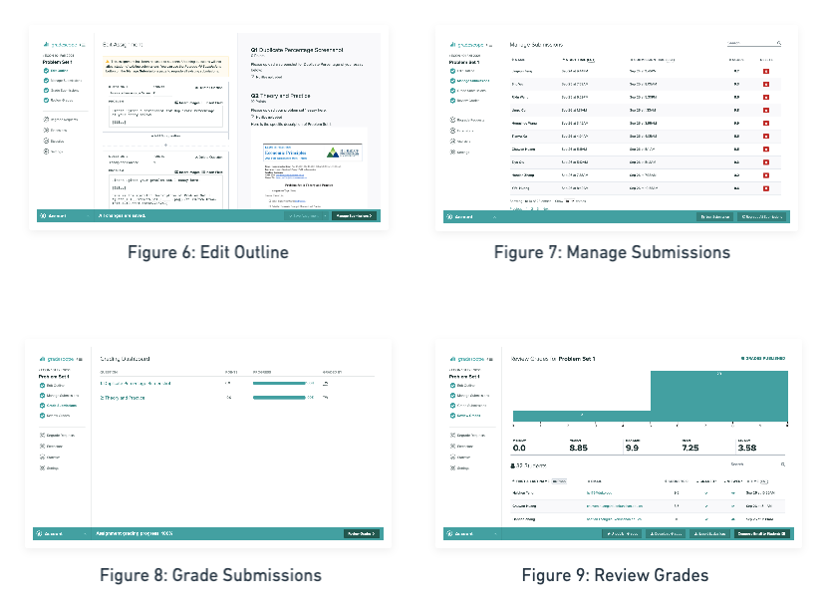

There are 4 functional pages in each assignment grading process that are not visible in student view:

1. Edit Outline: Allows instructors and TAs to edit the questions of the assignments.
2. Manage Submissions: Allows instructors and TAs to view the information of the submissions and review or delete any submission
3. Grade Submissions: Allow instructors and TAs to view the submission under each sub-question.
4. Review Grades: Provides statistics of the grading and allows instructors or TAs to review the assignments.

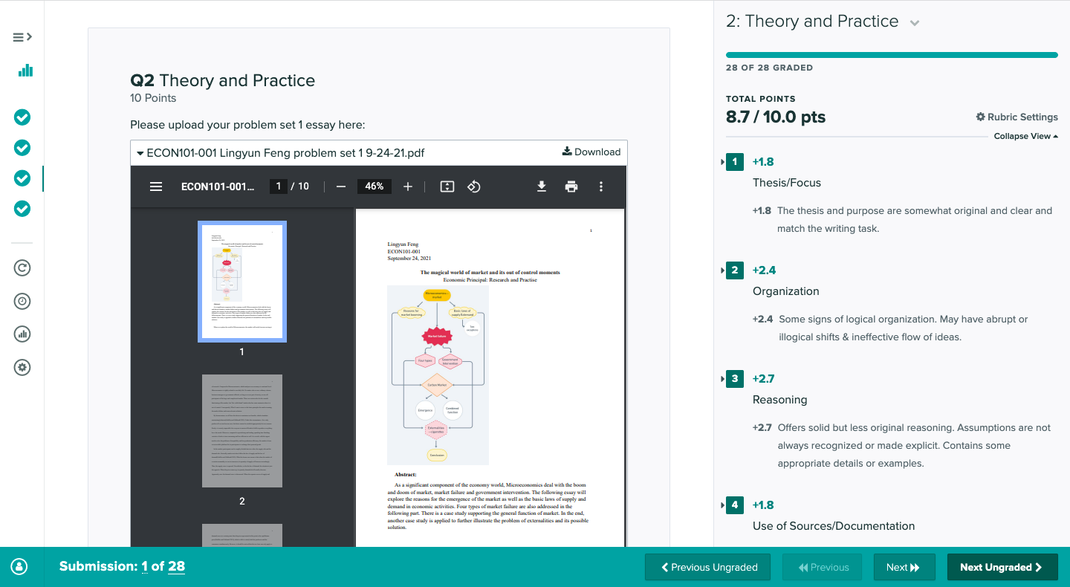

Figure 10: The sample grading page.

Figure 10 shows how instructors and TAs are able to grade the assignments with grading rubrics.

Pros:

1. **Clear rubrics feedback:** Students are able to get detailed feedback according to the grading rubrics and any extra comments.
2. **Specific answer position:** TAs and instructors can set up specific answer formats and the students can tag their answers in a certain place, which reduces the complexity in assignment grading.

Cons:

1. **Low tolerance for large files:** Gradescope requires instructors/TAs to download the large files to view the assignments. However, the tolerance is not very high since ___(to be filled with checks).
2. **Comments on certain positions in the essay:** Gradescope does not allow instructors/TAs to address in-text comments in certain positions.

# Code Assignment

Econ 211, Problem Set 3, Code Assignment

Pros: Not obvious.

Cons:

1. **Code editing environment not provided**

Gradescope does not provide an online editing environment like Google Colab. In other words, Gradescope does not allow students to edit coding assignments directly on its platform. Therefore, what we did is to provide a Google Colab template for students to download and after they finish coding in their own environments, they need to upload the file again to Gradescope for grading.

1. **Rubrics cannot be uploaded without a sample answer**

Gradescope does not allow the editors to generate rubrics unless a sample answer is uploaded.

1. **Is not a great way for grading assignments containing both code and text**

Gradescope provides an interface to let you write your own auto-grader for grading coding assignments. However, lots of Data Science related assignments are not proper to use as an auto-grader, because the code is used for solving a specific problem in many cases. Therefore, you are not able to use different inputs to test the universality of the code.

# The future of grading